DEPUTY MINISTRY OF SOCIAL WELFARE
APPLICATION FORM TO RECEIVE ITEMS VIA THE PROJECT
“BABY’ S DOWRY”

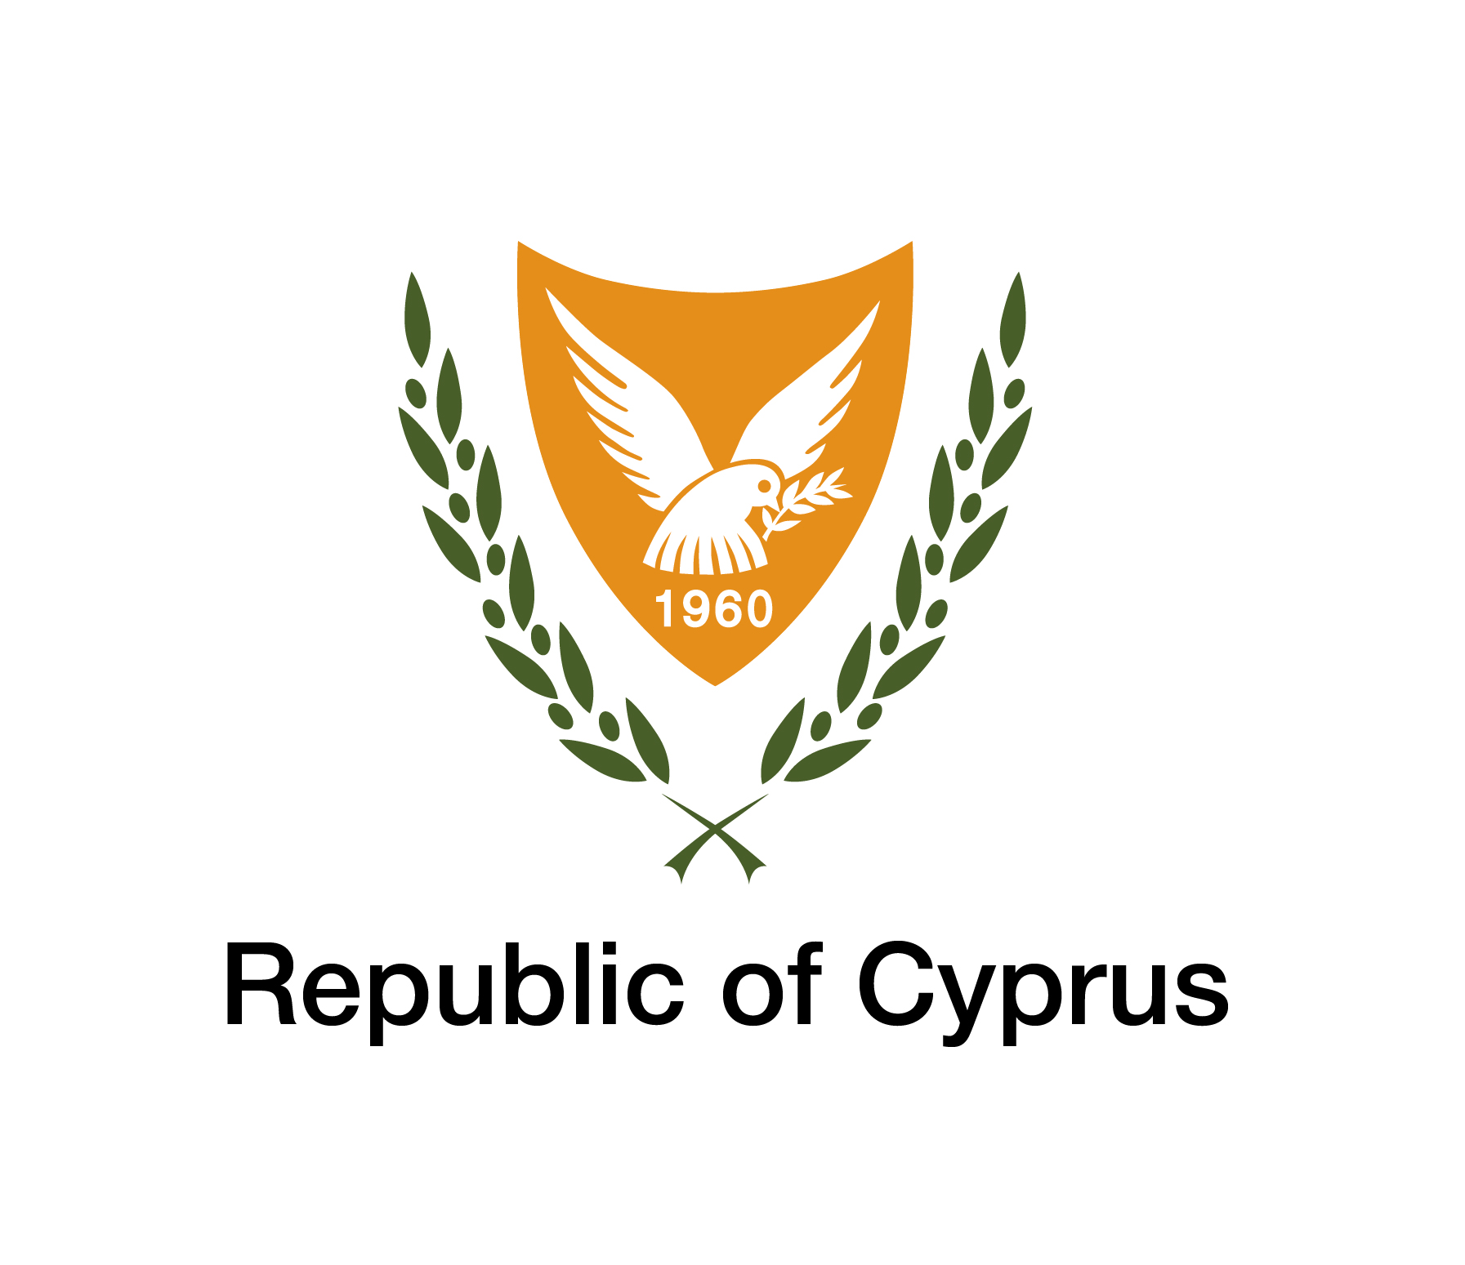

1. MOTHER’S PERSONAL INFORMATION (complete with CAPITAL letters where applicable)
Identification Card (ID) / ARC- Alien Registration Card |  |  |  |  | Social Insurance Number
Passport Number | Passport |  |  |  | Issuing Country
Mother’s name
Monther’s Surname
Nationality
Date of Birth |  | Place of birth (country)
   |  | /// |  |  | /
E-mail
Landline |  |  | Mobile phone
Married / Cohabitation Single-Parent

(α) Are you a recipient of Minimum Guaranteed Income (EEE); |  |  |  | YES Application number(EEE):  NO
(β) Are you a recipient of Public Assistance; |  |  |  | YES  SWS File Number:  NO
TO BE COMPLETED BY THE SOCIAL WELFARE SERVICES
(Not to be completed by the interested parties)
Εγκρίνεται / Απορρίπτεται
Ημερ.:……………....…. Υπογραφή:…………………………... Ονοματεπώνυμο: …………………………………………………..

Παρατηρήσεις: ………………………………………………………………………………………………………………………………...
…………………………………………………………………………………………………………………………………………………...

2. HUSBAND’S /FATHER’S PERSONAL INFORMATION ( complete with CAPITAL letters where applicable )
ID number / Alien Registration Card (ARC) |  |  |  | Social Insurance number
Passport Number |  |  |  | Passport Issuing Country
Name
Surname
Nationality
Date of Birth |  | Place of Birth(country)
   |  | /// |  |  | /
E-mail:
Landline: |  |  | Mobile phone:

3. ADDRESS OF RESIDENCE
Street
Number | Apt. | Name of Building
Municipality

Postal Code |  | District

4. Information of the child/children who is/are about to receive “Baby’s Dowry”

(α) If the child has been born, please complete the following information: | Date of Birth of child/children  Number of children who have been born  Name/Surname of child/children:  ID Card / Alien Registration Card (ARC):  Nationality of the  Child/children:  NOTE: The Certificate of Birth of the child/children MUST be attached on the application form when it is submitted.
   |  | ///// |  |  | /
   |  | ///// |  |  | /
   |  | ///// |  |  | /
   |  | ///// |  |  | /
(β) If the child has not been born yet: | Date of expected birth  Number of children to be born  ΣΗΜΕΙΩΣΗ: (1) Your Obstetrician MUST provide you with a confirmation letter that states the expected date of the delivery of the child/children. This letter should be attached on the application form when it is submitted. The Obstetrician’s confirmation letter MUST state whether more children are expected to be born (twins, triplets),  (2) The certificate of birth MUST be delivered to the Social Welfare Services within 30 (thirty) days of the child’s birth
   |  | /// |  |  | /

5. LIST OF ITEMS THAT ARE INCLUDED IN “BABY’S DOWRY” | 5. LIST OF ITEMS THAT ARE INCLUDED IN “BABY’S DOWRY”
Items | Please tick () the items that you need
Baby stroller/carrier

Baby cot

Mattress for the baby cot

Relax/feeding chair

Baby bathtub (stand included)

Diaper changing dresser

Sheets for the baby cot :

-2 sets of winter sheets

-2 sets of summer sheets

Blankets for the baby cot :

-2 sets of winter blankets

-2 sets of summer blankets

Towels :

-2 hooded towels

-2 towels without a hoodie

Pillow (to prevent acid reflux)

Diapers

Baby wipes

Special Package

2 big baby bottles (nipples included)

2 small baby bottles (nipples included)

2 pacifiers for babies up to 6 months old

2 pacifiers for babies 6+ months

12 baby body and hair wash products

12 baby lotions

12 Diaper Rash creams

1 set of baby nail clippers

1 comb and brush

1 baby thermometer (digital)

1 bath thermometer

6. AUTHORIZATION
I authorize the Social Welfare Services to deliver the items I have stated I need on the list mentioned above, to my place of residence. My contact number and address will be given to the distributor who has signed an agreement with the Social Welfare Services to provide items to the recipients of the Baby’s Dowry.

____________________  Mother’s Signature  ____________________  Name and surname | _____________________  Husband’s/Father’s signature  ____________________  Name and surname

IMPORTANT NOTE

In case your application is approved you MUST do the following:

(α) | Please send all the required documents (certificates, etc) within the time frame that is required
(β) | Participate in accompanying measures (informative actions) in order to tackle social exclusion of the families and in particular of the children.
(γ) | Inform the Social Welfare Services in writing of any changes that may occur before the deliverance of the requested items.

PLACES OF SUBMISSION

Τhis form should be delivered by hand or to be posted to the Social Welfare Services. The interested parties can submit them to the following offices:

-Nicosia District Welfare Office, 66 St Ilarionos Street, Kaimakli, Postal Code 1026, tel. 22804607
-Lakatamia Social Welfare Office, 23 Kennedy Street, Lakatamia, Postal code 2314, tel. 22608400
-Latsia Social Welfare Office, III Arch. Makarios 34, , Αρχ.Μακαρίου ΙΙΙ 34, Postal code 2220, tel. 22803500
-Limassol Social Welfare Office, 80 Franklin Rousvelt Street, Postal Code 3012, tel. 25 804452
-Polemidia Social Welfare Office, 3, 82 Road, Postal Code 4153, Kato Polemidia, tel. 25821895
-Zakakiou Social Welfare Office, 80 Franklin Rousvelt Street, Postal code 3012, Limassol, or PO box 71032, tel.25804539
-Germasogia Social Welfare Office, 73 Agias Zonis and Tyrteou Corner, Postal Code 3090, Limassol, tel. 25811660
-Larnaka District Welfare Office, 23-25 Piliou Street, PO Box 40184, Postal Code 6301 tel. 24800260
-Kamares Social Welfare Office, 23-25 Piliou Street, PO Box 40184, Postal Code 6301, Larnaka, tel. 24800207
-Agioi Anargyroi Social Welfare Office, 54 Ayioi Anargyroi Avenue, Postal code 6301 or P.O Box 40184, tel. 24821080
-Paphos District Welfare Office, 17 Nikou Nikolaides Street, Postal Code 8010, Paphos, P.O Box 60018, tel 26 821600 / 26 821602
-Ammochostos District Welfare Office, 170 1st April Street, Postal Code 5280, Paralimni PO Box 33065, tel. 23 811720

 | Certificates that must be attached to the application | Tick (√) the documents that you have included
1 | Copies of IDs / ΑRC of the members of the families
2 | (α) In case that the child has not been born yet, the Obstretician must provide the parents with an original confirmation letter that states the expected date of birth of the child. A certified copy is also accepted.  (Information regarding twins or triplets, should be included in the confirmation letter)
3 | (β) If the child has already been born, please provide a copy of their certificate of birth.

TO BE COMPLETED BY THE INTERESTED PERSON
I declare that all the information written above is true. In case there have been false statements or misleading information or even the slightest change in the facts mentioned above, I am aware that the Social Welfare Services may set conditions and/or suspend the supply of items that are included in “Baby’s Dowry.” I am also aware that in case I have received items from the “Baby’s Dowry” that I am not entitled to, I am obliged to return them.
If there are any circumstances that affect my inclusion in the "Baby’s Dowry", I will inform the Social Welfare Services in reasonable time and before the delivery of the items included in the Scheme.

I authorize the Social Welfare Services of the Deputy Ministry of Social Welfare to verify in cooperation with other competent authorities any of the information stated in my Statement they deem necessary.

The interested parties (mother, husband/father) must complete Article 6 of the Application Form.
The data contained in this Application Form will be used for the creation of the Register of beneficiary families which will serve to monitor the delivery of the "Baby’s Dowry" and the accompanying measures, as well as to extract the required statistical data. Also, the data may be processed anonymously for the purpose of evaluating the Scheme.

Date of submission | ____________________  Signature of the mother | _____________________  Signature of husband/father
   | / |  |  | /
INFORMATION PROVIDED REGARDING ARTICLE 11 OF THE PERSONAL DATA PROCESSING (PROTECTION OF THE INDIVIDUAL) LAW OF 2001 (L.138(I)/2001)

Personal data concerning you and which are processed by the Social Welfare Services, are protected by the legislation on the protection of natural persons with regard to the processing of personal data and on the free movement of such data [Regulation (EU) 2016/679 and Law 125 (I) / 2018, as amended and/or replaced]

The recipients of the data will be the personnel of the Social Welfare Services. The personal data included in the records kept by the Social Welfare Services may be communicated or transmitted between the government departments involved. The management and processing of my personal data will be performed securely and with confidentiality and will be subject to the relevant provisions of the applicable legislation.

I am also informed that I have the right to access information and object to the Articles11, 12 and 13 of Law 138(I)/2001. I can contact the Social Welfare Services in such case. In case of any disagreement/objection I may have, regarding the conduct of communication by certain means, I have the right to notify the Social Welfare Services in writing.

